**Product Dissection for LinkedIn**

**Company Overview**

LinkedIn, founded in 2002 by Reid Hoffman, has evolved into the world's largest professional networking platform. Acquired by Microsoft in 2016, LinkedIn is renowned for its role in connecting professionals, facilitating career growth, and fostering industry insights. With over 740 million members worldwide, LinkedIn has redefined professional networking, offering a platform for personal branding, recruitment, and business development.

**Product Dissection and Real-World Problems Solved by LinkedIn**

LinkedIn has effectively addressed critical challenges in professional networking through its innovative product offerings. With a focus on professional connections and career development, LinkedIn empowers users to build meaningful relationships, explore career opportunities, and showcase their professional achievements. By enabling users to create detailed profiles, share updates, and engage in industry-specific conversations, LinkedIn bridges geographical and industry divides, fostering a global community of professionals.

LinkedIn's robust features, such as endorsements, recommendations, and skill endorsements, enhance credibility and visibility within professional networks. These features address the challenge of validating skills and expertise in a competitive job market, helping users differentiate themselves and attract opportunities aligned with their career aspirations

In conclusion, LinkedIn's product design has successfully tackled real-world challenges by creating a platform that facilitates professional networking, career advancement, and industry knowledge sharing. Through its diverse features, LinkedIn addresses the need for authentic professional engagement, career growth opportunities, and meaningful connections, shaping the global landscape of professional networking.

**Case Study: Real-World Problems and LinkedIn's Innovative Solutions**

LinkedIn stands out as a premier professional networking platform, effectively addressing key challenges in today’s job market and business landscape.The platform’s robust search and filtering capabilities make it easier for employers to find qualified candidates, addressing the talent acquisition challenges many face today. LinkedIn’s content sharing and engagement tools empower users to share insights, industry trends, and expertise, fostering a culture of continuous learning and professional development.

**Problem 1: Bridging Professional Networking Gaps**

**Real-World Challenge:** As professionals seek to expand their networks beyond local boundaries, the challenge of building and maintaining meaningful professional relationships becomes crucial.

**LinkedIn's Solution:** LinkedIn recognized the need for a platform dedicated to professional networking. By allowing users to create comprehensive profiles that showcase their professional experiences, skills, and educational background, LinkedIn facilitates authentic connections. The platform's emphasis on professional updates, industry insights, and thought leadership articles fosters ongoing engagement, enabling professionals to bridge networking gaps and build global connections effectively.

**Problem 2: Career Advancement and Job Search**

**Real-World Challenge:** Navigating career transitions and exploring job opportunities can be daunting without access to a broad network and relevant industry insights.

**LinkedIn's Solution:**LinkedIn addresses the challenge of career advancement through its job search and recruitment features. The platform's job postings, tailored job recommendations, and recruiter connections provide users with direct access to career opportunities aligned with their skills and aspirations. LinkedIn's proactive approach to career development, including professional courses and certifications, empowers users to enhance their skills and stay competitive in their respective industries.

**Problem 3: Information Overload**

**Real-World Challenge:** The sheer volume of content on the internet can overwhelm users, making it difficult to find relevant and engaging professional insights.

**LinkedIn's Solution:** LinkedIn addresses content overload through its personalized feed and algorithm-driven content recommendations. By curating updates and articles tailored to users’ interests and professional fields, LinkedIn enhances the user experience, ensuring that professionals stay informed about topics that matter to them.

**Problem 4: Building Professional Branding**

**Real-World Challenge:** Establishing a strong professional brand that resonates with industry peers and potential employers can be challenging in a competitive market.

**LinkedIn's Solution**: LinkedIn offers users a platform to build and showcase their professional branding through detailed profiles, project showcases, and multimedia content. The platform's customizable profile sections, including headline, summary, and multimedia portfolio, allow users to highlight their achievements and unique value proposition effectively. LinkedIn's networking events and groups further facilitate brand building by connecting users with like-minded professionals and industry influencers.

**Conclusion**

LinkedIn's evolution from a simple networking site to a comprehensive professional platform highlights its ability to identify and address real-world challenges. By nurturing genuine connections, curating content, supporting career growth, and enabling effective personal branding, LinkedIn provides innovative solutions that resonate with its global user base. This approach solidifies LinkedIn's position as a leader in the professional networking domain, continually shaping how we connect and engage in the workplace.

**Top Features of LinkedIn**

* **User Profiles:** Detailed profiles showcasing professional experiences, skills, and endorsements.
* **Connections:** Building and maintaining professional relationships through connections and networking.
* **Jobs:** Access to job postings, job recommendations, and recruiter connections.
* **Content Sharing:** Publishing articles, sharing updates, and participating in industry-specific discussions.
* **Skills and Endorsements**: Validating professional skills through endorsements and recommendations.
* **Groups and Events:** Joining professional groups and attending networking events to expand networks.

**Schema Description for LinkedIn:**

The schema for LinkedIn involves various entities that represent different aspects of the platform:

**User Entity:**

* **UserID (Primary Key)**: A unique identifier assigned to each user.
* **Username**: The custom username chosen by the user for their profile.
* **Email**: The email address used for account communication and notifications.
* **Full_Name**: The name displayed on the user’s profile.
* **Headline**: A brief statement summarizing the user’s professional identity.
* **Summary**: A detailed overview of the user’s career and skills.
* **Profile_Picture_URL**: The URL linking to the user’s profile picture.
* **Registration_Date**: The date when the user created their LinkedIn account.

**Connection Entity:**

* **ConnectionID (Primary Key)**: A unique identifier for each connection between users.
* **UserID (Foreign Key referencing User Entity)**: The ID of the user initiating the connection.
* **Connected_UserID (Foreign Key referencing User Entity)**: The ID of the user being connected to.
* **Connection_Date**: The date when the connection was established.

**Job Entity:**

* **JobID (Primary Key)**: A unique identifier for each job entry.
* **UserID (Foreign Key referencing User Entity)**: The ID of the user associated with the job.
* **Company_Name**: The name of the company where the user worked.
* **Job_Title**: The title of the position held by the user.
* **Employment_Duration**: The time period the user was employed in the job.
* **Job_Description**: A summary of the user’s responsibilities and achievements in the role.

**Post Entity:**

* **PostID (Primary Key)**: A unique identifier for each post created by a user.
* **UserID (Foreign Key referencing User Entity)**: The ID of the user who created the post.
* **Post_Content**: The content shared in the post.
* **Post_Date**: The date when the post was published.

**Comment Entity:**

* **CommentID (Primary Key)**: A unique identifier for each comment made on posts.
* **PostID (Foreign Key referencing Post Entity)**: The ID of the post being commented on.
* **UserID (Foreign Key referencing User Entity)**: The ID of the user who made the comment.
* **Comment_Content**: The text of the comment provided by the user.
* **Comment_Date**: The date when the comment was posted.

**Like Entity:**

* **LikeID (Primary Key)**: A unique identifier for each like given to a post.
* **PostID (Foreign Key referencing Post Entity)**: The ID of the post being liked.
* **UserID (Foreign Key referencing User Entity)**: The ID of the user who liked the post.
* **Like_Date**: The date when the like was recorded.

**Endorsement Entity:**

* **EndorsementID (Primary Key)**: A unique identifier for each skill endorsement.
* **Endorsed_UserID (Foreign Key referencing User Entity)**: The ID of the user being endorsed.
* **Endorsing_UserID (Foreign Key referencing User Entity)**: The ID of the user providing the endorsement.
* **Skill_Endorsed**: The specific skill being endorsed.
* **Endorsement_Date**: The date when the endorsement was made.

**Relationships:**

* Users connect with other Users (many-to-many)
* Users post Posts (one-to-many)
* Posts receive Comments (one-to-many)
* Users like Posts (many-to-many)
* Users endorse other Users' Skills (many-to-many)

**Creating the ER Diagram:**

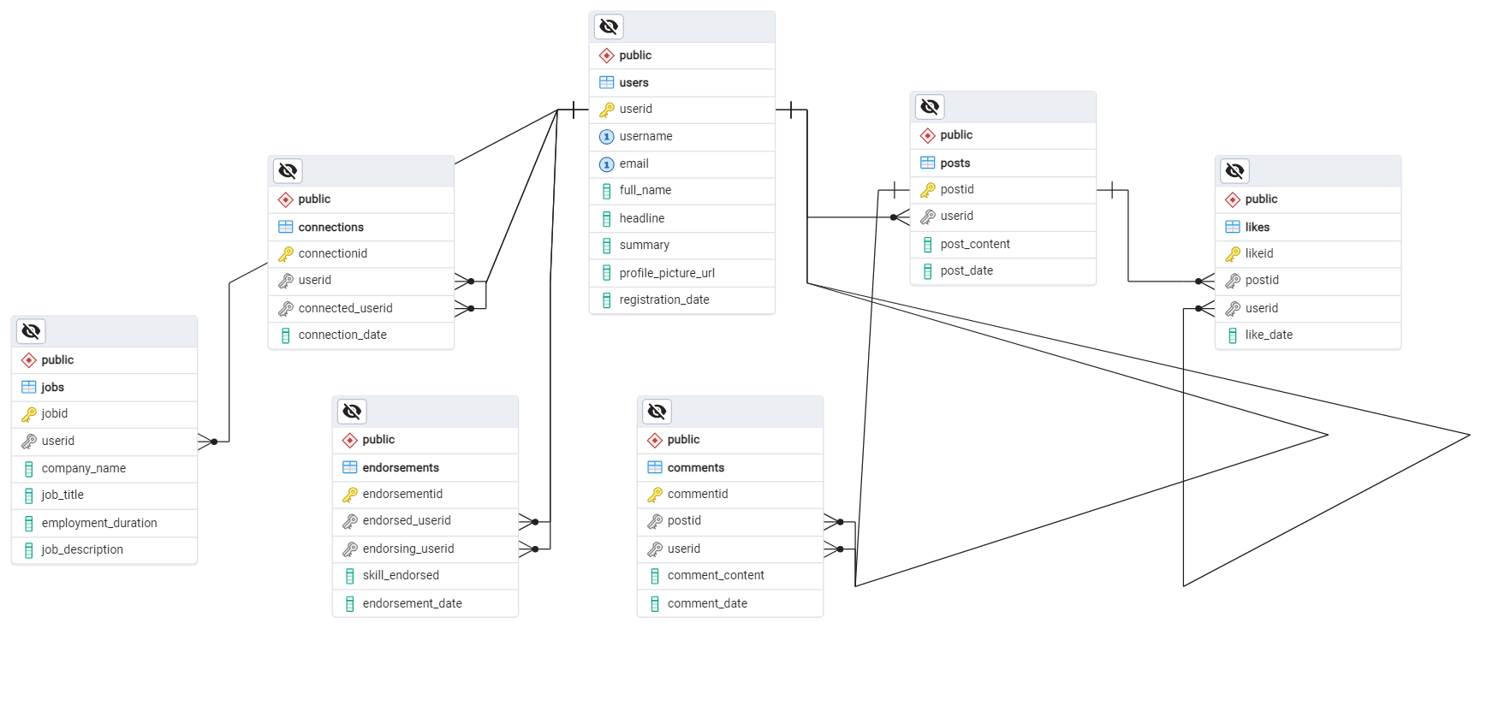

## **Conclusion**

This case study illustrates how LinkedIn has revolutionized professional networking and career development. By understanding its intricate schema and user-centric approach, we gain insight into how LinkedIn effectively manages user interactions and content sharing, contributing to its popularity and growth in the social media landscape.